Randolph Republican Club
2023 Renewal/Membership Application
Please complete the form below and send it with a check payable to Randolph Republican Club or complete QR Code.

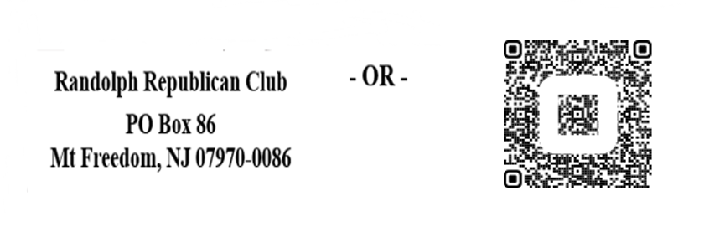

Annual Membership: $60 per person
New (Circle One) Renewal
The Club needs the personal information requested because it is required by the New Jersey Election Law Enforcement Commission (NJ ELEC) as part of the quarterly financial reports the Club is required to file. Note: QR Code users will be subsequently contacted by the club for employment information per NJ ELEC requirements if we do not have record of your employer information.

Name: E-Mail
Phone/Cell preferred: ____________________________________________________________
Address

Occupation Employer Employer’s Address

Please consider making an additional, voluntary contribution. We need to get our messages out and vigorously support our candidates. That requires resources.

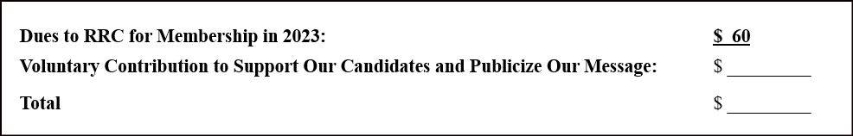

Membership Prerequisite: Must be a Registered Republican.

